Aim : Implement Different Types of Joins in SQL
A JOIN is used to combine rows from two or more tables based on a related column.
1. Create Tables
2. Insert Values
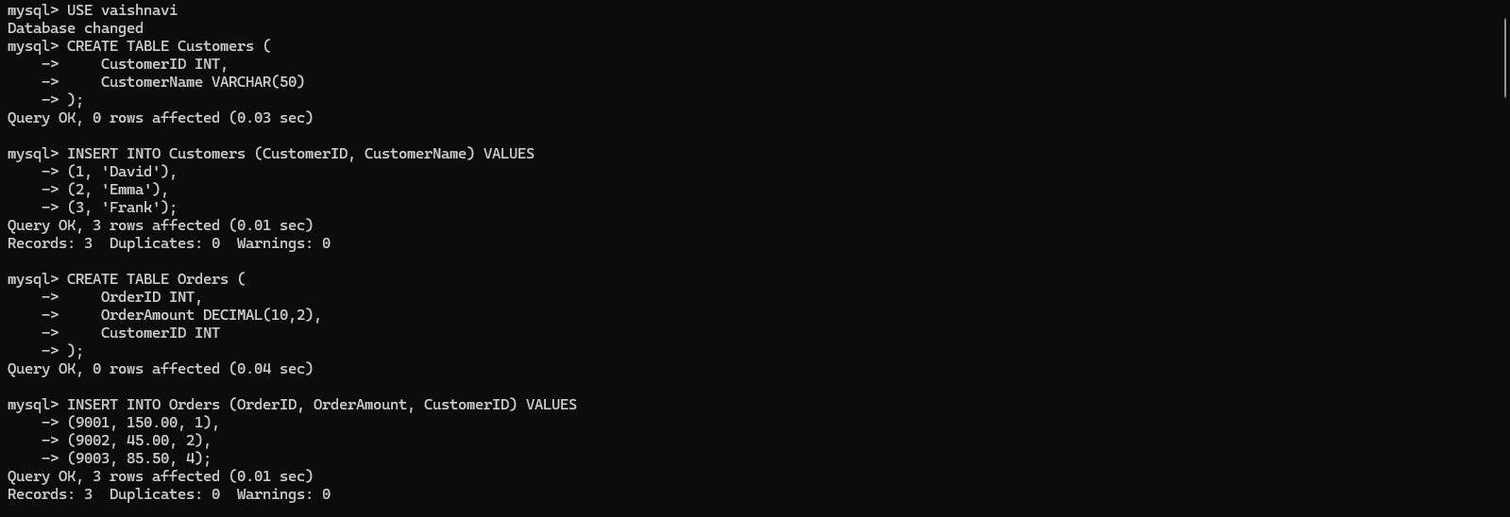
1. INNER JOIN
An INNER JOIN returns only the rows that have matching values in both tables.
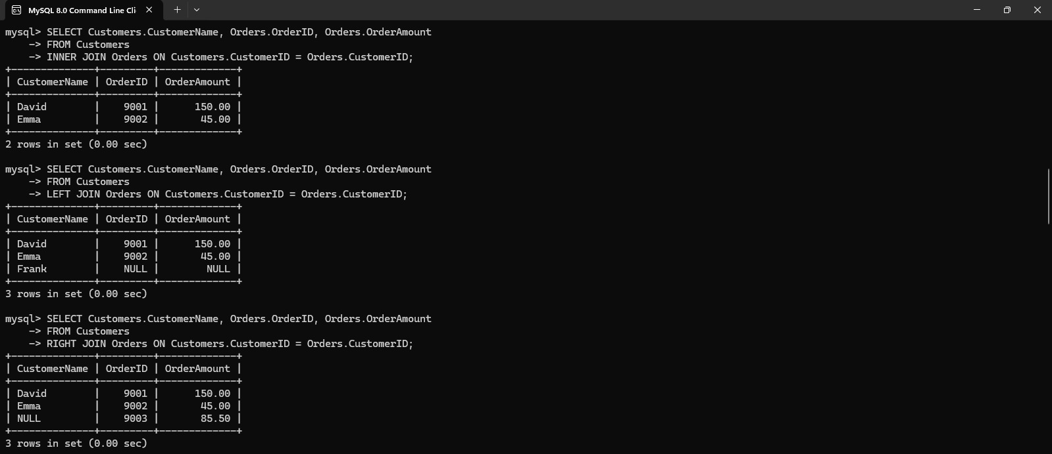

2. LEFT OUTER JOIN
A LEFT JOIN returns all rows from the left table and matching rows from the right table.
3. RIGHT OUTER JOIN
A RIGHT JOIN returns all rows from the right table and matching rows from the left table.
4. FULL OUTER JOIN
A FULL OUTER JOIN returns all rows from both tables. Matching rows are combined, and non-matching rows contain NULL.
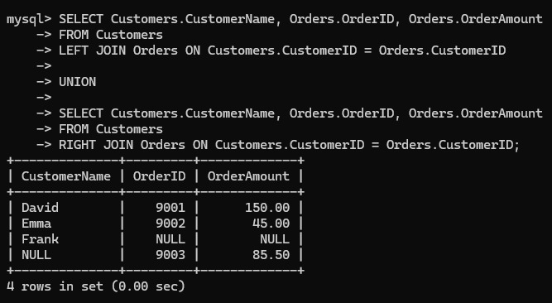

Note: MySQL does not directly support FULL OUTER JOIN; it can be implemented using LEFT JOIN, RIGHT JOIN, and UNION.

5. CROSS JOIN
A CROSS JOIN produces the Cartesian product of two tables. It combines each row of the first table with every row of the second table.
SELECT Student.Student_Name, Course.Course_Name
FROM Student
CROSS JOIN Course;
If there are 4 students and 4 courses, the result will contain:
4 × 4 = 16 rows
Example output:
Student_Name | Course_Name
Rahul | BCA
Rahul | BBA
Rahul | BCom
Rahul | MCA
Priya | BCA
Priya | BBA
... | ...
👉 No ON condition is required for a CROSS JOIN.

6. SELF JOIN
A SELF JOIN means joining a table with itself.
For example, create an Employee table:
CREATE TABLE Employee (
Employee_ID INT,
Employee_Name VARCHAR(50),
Manager_ID INT
);
Insert values:
INSERT INTO Employee VALUES
(101, 'John', NULL),
(102, 'Rahul', 101),
(103, 'Priya', 101),
(104, 'Amit',102);
Here:
- John → Manager
- Rahul → John's employee
- Priya → John's employee
- Amit → Rahul's employee
Query
SELECT
E.Employee_Name AS Employee,
M.Employee_Name AS Manager
FROM Employee E
LEFT JOIN Employee M
ON E.Manager_ID = M.Employee_ID;
Output
Employee | Manager
John | NULL
Rahul | John
Priya | John
Amit | Rahul
Here, Employee is used twice:
- E represents the employee.
- M represents the manager.

Final list of joins
- INNER JOIN → Only matching rows
- LEFT OUTER JOIN → All left table rows + matching right rows
- RIGHT OUTER JOIN → All right table rows + matching left rows
- FULL OUTER JOIN → All rows from both tables
- CROSS JOIN → Every possible combination of rows
- SELF JOIN → A table joined with itself
Conclusion: Joins are used to retrieve/select related data from multiple tables efficiently based on common columns.

